Name: Goran Jeftenic
E-mail: goran.jeftenic@uns.ac.rs
Institution: University of Novi Sad, Faculty of Technical Sciences
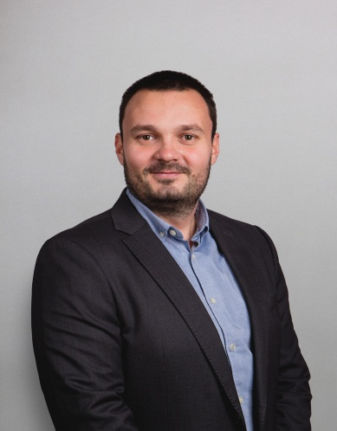 | Goran Jeftenic is assistant at the Faculty of Technical Sciences, University of Novi Sad, Department of Civil Engineering and he is engaged in development and realization of the following subjects: Hydrotechnical Facilities and systems, Basics of Hydromechanics and Hydrotechnics, Hydrotecnhical Meliorations, Fundamentals of Water Protection, Water Treatment Methods and Technologies.  Goran Jeftenic is author and co – author of more than 30 scientific papers which are published in national and international conference.  Research interest: Municipal Hydrotechnics, Water Supply Systems, Sewage Systems, Wastewater treatment, Small hydro power plants.
References (max. 5 relevant references)
- Sr. Kolakovic, I. Pesko, V. Mucenski, S. Ilincic, A. Lalosevic, Z. Madzgalj, Sl. Kolakovic, G. Jeftenic, D. Bibic, A. Vujkov, “REVITALIZATION OF THE BEGEJ CANAL - CURRENT STATE, PLANED ACTIVITIES AND COST-BENEFIT ANALYSIS”, International Scientific Conference People, Buildings and Environment 2016 (PBE2016) 29 September – 1 October, 2016, Luhacovice, Czech Republic, www.fce.vutbr.cz/ekr/PBE
- B. Radakovic, G. Jeftenic, Sl. Kolakovic, I. Pesko, V. Mucenski, S. Kovacevic “EFFECT OF OXIC CONDITIONS ON BEHAVIOR OF POLLUTANTS IN GROUNDWATER”, International Scientific Conference People, Buildings and Environment 2016 (PBE2016) 29 September – 1 October, 2016, Luhacovice, Czech Republic, www.fce.vutbr.cz/ekr/PBE
- G.Jeftenić, Sl. Kolaković, S. Ožvat, S. Vujović, B. Mašić, “DETERMINATION OF FLOW REGIME ON THE LAKE TIKVARA NEAR BACKA PALANKA “,International Conference GNP, Zabljak, Montenegro, 2014.
- S. Vujović, Sr. Kolaković, B. Mašić, Sl. Kolaković, G. Jeftenić, ,, The Assessment of the Danube and Tisza water quality in Serbia'' 3rd International Conference „ECOLOGY OF URBAN AREAS 2013“ Faculty of technical Sciences ,,Mihajlo Pupin'' Zrenjanin, University of Novi Sad, Serbia, 11th October 2013, Zrenjanin
- Stipic D., Vasic M., Djogo M., Jeftenic G., Kolakovic S. Analysis of seepage control and slope stability of the embankment dam “Vranas”. International jubilee conference: science and technic, “70 years faculty of hydraulic engineering”, Faculty of hydraulic engineering, Sofia, Bulgaria, 2019.

This project has been funded with support from the European Commission. This publication reflects the views only of the author, and the Commission cannot be held responsible for any use which may be made of the information contained therein.

